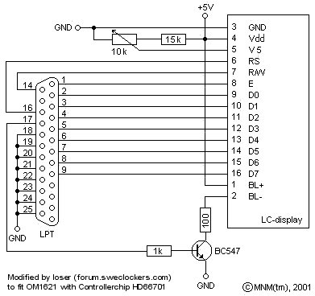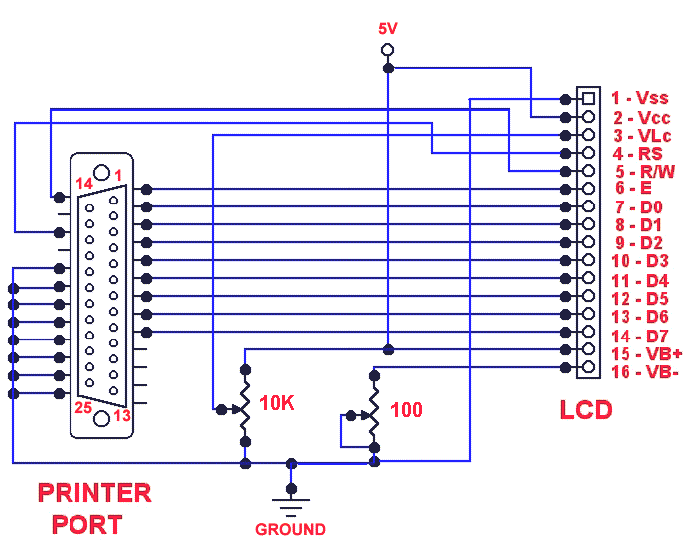

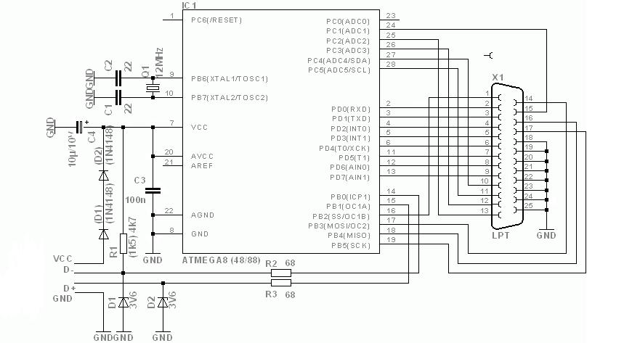

LCD Pin Number Symbol Function Parallel/Power Connection
1 Vss Display power ground Molex ground (either black wire)
2 Vdd Display power +5V Molex +5v (red wire)
3 Vo Contrast Adjust. Altered by adjusting the voltage to this pin, grounding it sets it to maximum contrast. * Molex ground (either black wire)
4 RS Register select Parallel pin 16
5 R/W Data read/write selector. Its possible to read information from a display however there's no need for it here so grounding it sets it permanently write. Molex ground (either black wire)
6 E Enable strobe Parallel pin 1
7 DB0 Data Bus 0 Parallel pin 2
8 DB1 Data Bus 1 Parallel pin 3
9 DB2 Data Bus 2 Parallel pin 4
10 DB3 Data Bus 3 Parallel pin 5
11 DB4 Data Bus 4 Parallel pin 6
12 DB5 Data Bus 5 Parallel pin 7
13 DB6 Data Bus 6 Parallel pin 8
14 DB7 Data Bus 7 Parallel pin 9
15 A LED backlight power +5v Molex +5v (red wire)
16 K LED backlight power ground Molex ground (either black wire)

